**Jack Ryan Season 3: Release date and other details!** 

**Jack Ryan**, an American governmental action thriller, *amazon prime* original, television *series*, grounded on 'Ryanverse' written by Tom Clancy. It was first *premiered* on August 31, 2018. The series was created by Carlton Cuse and Graham Roland and produced by Nazrin Choudhary, Jose Luis Escolar, and Robert Philips. Season 2 was *released* on October 31, 2019. Amazon renewed the series for *season 3* in April 2019. So, let's see the progress in the *season 3* production in the following paragraphs.

**Jack Ryan Season 3: Release Date**

There's no official announcement from the creator or distributor side regarding the **release date** of **season 3** of the series. Since, the renewal news for *season 3* came in April 2019 so from that time the *season 3* production was in continuation until the lockdown, because of the pandemic which curbed the shooting of the series which has not yet restarted. Filming of the series can begin at any time in 2021 as soon as the infection chances from the covid-19 decrease after the vaccination. So, it's highly likely that *season 3* will be **premiered** by late 2021 or in the first half of 2022.

**Jack Ryan Season 3: Probable Cast**

Most of the lead actors of the series are likely to repeat their characters. Few of them are:

John Krasinski being **Dr. Jack Ryan**, a financial analyst who works for the Central Intelligence Agency (CIA), especially the Terror, Finance, and Arms Division (T-FAD) under the counterterrorism Center (CTC). He's an ex-marine veteran.

Wendell Pierce being James Greer, Ryan's leader in T-FAD, a non-practicing Muslim, ex-CIA station leader in Karachi, and ex-deputy station leader in Moscow, currently working in Venezuela.

Abbie Cornish being Dr. Cathy Mueller, Ryan's love interest, and a physician specializing in infectious disease. 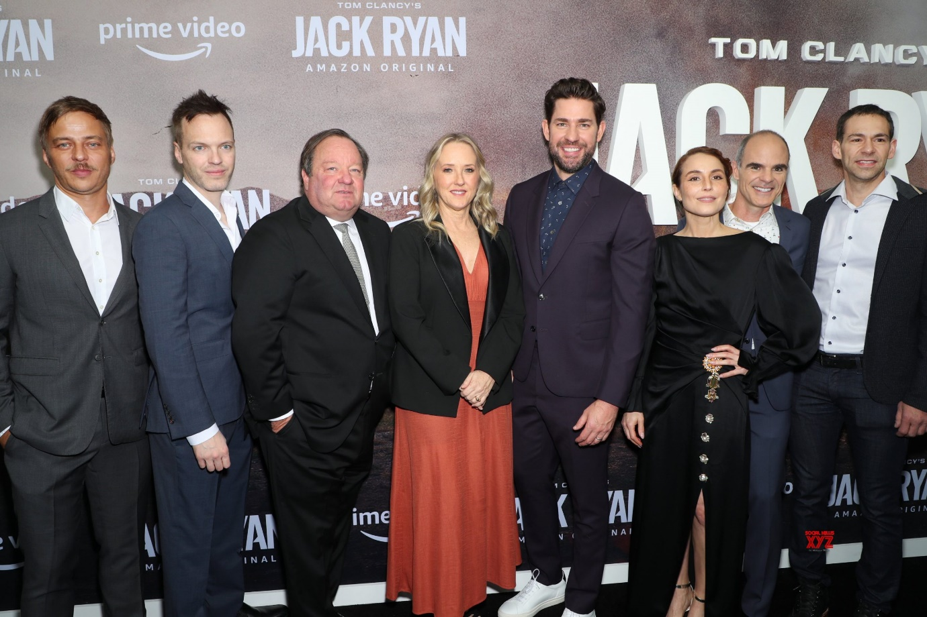

Michael Kelly being Mike November, CIA station leader in Venezuela.

Noomi Rapace being Harriet "Harry" Baumann, a german Federal Intelligence Service agent.

Jovan Adepo being Marcus Bishop, an ex-U.S. Navy special crewman

Jordi Molla being Nicolas Reyes, President of Venezuela

Cristina Umana being Gloria Bonalde, the major Venezuelan Presidential candidate.

Francisco Denis being Miguel Ubarri, President Reyes' chief advisor and childhood pal.

Of all these characters Kelly, Rapace, and Adepo seem the most likely to appear in *season 3* apart from the protagonist actors.

Abbie Cornish's re-entry if happens is the most awaited event of the season.

Additionally, according to some sources, Marianne Jean- Baptiste will be appearing in **season 3** as Elizabeth Wright.

**Jack Ryan Season 3: Expected Plot**

In all the previous seasons, we saw some governmental affairs like a national ultimatum from Islamic radicals and an unscrupulous presidential election in Venezuela. Like in the first *season*, we saw Islamic radical tantrum of uncertain bank transfers, on finding which Jack gets ripped from the security of his desk job into that banking sector. In the second *season*, we saw the corruption in the Venezuela presidential election which was even related to nuclear weapons somehow. So, we can anticipate that **Jack Ryan** will again be remitting some state affairs and there're multiple possibilities for the same.

**Jack Ryan Season 3: Trailer**

Since the filming of the *season* is not yet complete, so there's no *release* of the **trailer** of **season 3**. It's likely to be **premiered** by late 2021 or in the first half of 2022. Till that time, you can enjoy the *trailer* of *Jack Ryan Season* 2😊

https://www.youtube.com/watch?v=Un2zXkM-03U